Chanukah Blessings
Happy Chanukah from totshabbat.com

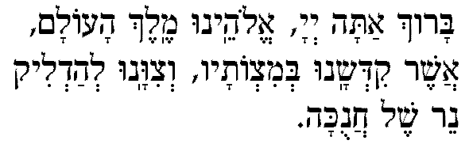
Blessed is the Eternal our God, Ruler of the universe, Who hallows us with mitzvot and who commands us to kindle the Chanukah lights.

Baruch Atah Adonai Eloheinu Melech ha-olam asher kidshanu b’mitzvotav
Vitzivanu l’hadlich ner shel Chanukah.

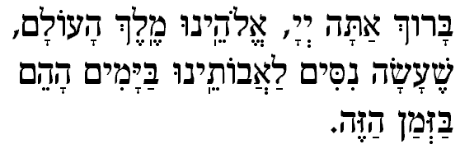
Blessed is the Eternal our God, Ruler of the universe, who performed miracles for our ancestors in days of old at this season.

Baruch Atah Adonai Eloheinu Melech ha-olam, She-ah-sah nisim la-avoteinu bayamim hahem bazman hazeh.

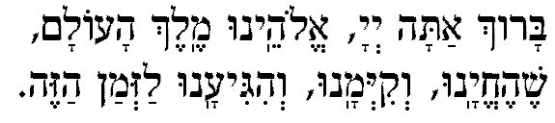
First night only:

Blessed is the Eternal our God, Ruler of the Universe, who has kept us alive, and has preserved us, and enabled us to reach this season.

Baruch Ata Adonai, Elohenu Melech ha-olam
She-hecheyanu, ve-kiyemanu, ve-higiyanu laz’man ha-zeh.

1. Light One Candle by Peter Yarrow

Light one candle for the Maccabee children. Give thanks that their light didn’t die.
Light one candle for the pain they endured when their right to exist was denied.
Light one candle for the terrible sacrifice justice and freedom demand.
Light one candle for the wisdom to know when the peacemaker’s time is at hand.

Chorus: Don’t let the light go out.
It’s lasted for so many years.
Don’t let the light go out.
Let it shine through our love and our tears.

Light one candle for strength that we need to never become our own foe.
Light one candle for those who are suffering the pain we learned so long ago.
Light one candle for all we believe in, let anger not tear us apart.
Light one candle to bind us together with peace as the song in our heart. Chorus

What is the memory that’s valued so highly that we keep alive in that flame.
What’s the commitment to those who have died when we cry out “They’ve not died in vain.”
We have come this far always believing that justice will somehow prevail.
This is the burden and this is the promise and this is why we will not fail. Chorus

2. Lots of Latkes arranged by A. Leider

Part I: Lots of latkes, lots of latkes, lots of latkes, lots! Let’s all eat ‘em up (x2)
Part II: S’vivon sov sov, s’vivon sov sov, s’vivon sov sov, s’vivon sov sov. (x2)
Part III: Maccabees, mac mac mac Maccabees, mac mac mac Maccabees, mac mac mac mac
mac mac mac mac mac mac mac mac, Maccabees, mac mac mac Maccabees, mac mac mac
Maccabees, mac mac mac Mac-ca-bees!

3. Oh Chanukah-folk melody

English verse by F. Minkoff

Oh Chanukah, oh Chanukah,
Come light the menorah,
Let’s have a party,
We’ll all dance the hora!
Gather ’round the table,
we’ll give you a treat,
S’vivon to play with, and
latkes to eat,
And while we are playing
The candles are burning low,
One for each night,
They shed a sweet light
To remind us of days long ago.

4. S’vivon Kipnis/Gewirtz/Kaelter
S’vivon, sov, sov, sov,
Chanukah hu chag tov,
Chanukah, hu chag tov,
S’vivon sov, sov, sov.

Chag simchah hu la-am

Neis ga-dol ha-yah sham!
Neis ga-dol ha-yah sham,
Chag simchah hu la-am!

5. How many candles?
by J. Cytrynbaum
How many candles? (x2)
How many candles do we light?
On our Hanukkiah, (x2)
On the first Hanukah night?
One! One! One-one-one!
One candle burning (x2)
On the first Chanukah night.

7. I have a Little Dreidel

I have a little dreidel,
I made it out of clay
And when it’s dry and ready
Then dreidel I shall play,

Oh dreidel, dreidel, dreidel,
I made it out of clay;
Oh dreidel, dreidel, dreidel,
Now dreidel I shall play.

It has a lovely body,
With legs so short and thin,
And when it gets all tired,
It drops and then I win!

8. Ner Li Words: L. Kipnis, Music: Daniel Sambursky

Ner li, ner li, Ner li dakik
Ba-Chanukah neri adlik.
Ba-Chanukah neri ya-ir
Ba-Chanukah shirim a-shir.
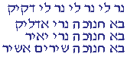
I have a candle,
A candle so light
On Chanukah my candle
burns bright.
On Chanukah
my light burns long,
On Chanukah
I sing this song.

9. Yodelaydo Potato by Peter and Ellen Allard

I like to eat potato latkes, I like to eat them all day
And when I eat potato latkes, this is what I say:

Yodelaydo potato, Yodelaydo potato
Yodelaydo potato latkes for me!
Yodelaydo potato, Yodelaydo potato,
Yodelay, Yodelay potato!

I like to eat them with applesauce…
I like to eat them at grandma’s table…
I like to eat them at Temple Shalom…

10. Maoz Tzur- Rock of AgesHebrew words by Mordechai, 13th century poet
English words: Marcus Jastrow, Gustav Gottheil
Ma-oz tsur y’shu-ati, l’cha na-eh l’shabei-ach
Ti-kon beit t’filati v’sham to-da n’zabei-ach
L’eit tachin mat-beiach mi’tzar ham’na-bei-ach
Az egmor b’shir mizmor Chanukat ha-miz-beiach (2x)

Rock of ages, let our song praise your saving power.
You amidst the raging foes were our shelt’ring tower.
Furious they assailed us, but your arm availed us.
And your word broke their sword when our own
strength failed us (2x)

Children of the Maccabees, whether free or fettered,
Wake the echoes of the songs,
Where you may be scattered.
Yours the message cheering, that the time is nearing,
Which will see, all people free, tyrants disappearing.

11. In the Window words by J. Eisenstein

In the window where you can see the glow
Of my menorah on newly fallen snow,
I will set you one little candle
On this the first night of Chanukah.

12. Ocho Kandelikas by Flory Jagoda

1. Chanukah linda sta aki, ocho kandelas para mi (2x)

Chorus O --- Una kandelika, dos kandelikas, tres kandelikas, kuatro kandelikas sintyu
kandelikas, sej kandelikas, siete kandelikas, ocho kandelas para mi

2. Muchas fiestas vo fazer, kon alegriyas y plazer
3. Los pastelikos vo kumer, kon almendrikas y la myel

13. Al Hanisim music by D. Frimer

Al hanisim v’al hapurkan v’al hag’vurot v’al hat-shu-ot
V’al ha-mil-cha-mot she-asita lavoteinu
Bayamim hahem bazman hazeh.

For the miracles, the rescues, the heroic acts, the victories, the battles that You waged for our ancestors in those days at this season.

6. Who Can Retell? Music by M. Ravina; English lyrics by B. M. Edidin, J. K. Eisensetin and others

Who can retell the things that befell us,
Who can count them?
In every age a hero or sage came to our aid.
Ah! At this time of year in days of yore,
Maccabees the Temple did restore.
And today our people as we dreamed,
Will unite, arise and be redeemed.

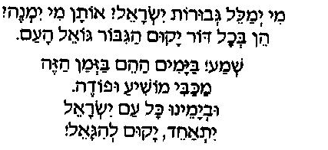
Mi y’ma-leil g’vu-rot Yisrael? O-tan mi yim-neh?
Hein b’chol dor ya-kum ha-gi-bor go-eil Ha-am.
Sh’ma! Ba-ya-mim ha-heim baz-man hazeh,
Ma-ka-bi mo-shi-a u-fo-deh,
Uv-ya-mei-nu kol am Yis-ra-eil,
Yit-a-cheid ya-kum v’hi-ga-eil.

